Requirement and Design Document

**Purpose**

The purpose of this document is to outline the functional requirement that will enable design and development of Online Sales Management System.

**Program Overview**

Online Sales Management System plays an integral part of any for successful marketing strategy. Managing sales force in an efficient and effective manner to perform better is the major challenge faced by many companies. Continuously motivating sales team, coordinating marketing and sales effort and salespeople management are the major challenges faced in many sales force management systems.

This application is maintained by a Senior manager who has the responsibility of two regions. A Region which hosts multiple sales outlets, is headed by a Regional sales manager. Sale outlets are led by sales managers. Spec senior manager monitors the sales report to take further decisions on the production of products, to position them in market share and to improvise the sales.

The team has a main warehouse which stores different models. Each sales outlet has its own inventory. Each of the sales manager will order for products of different models. The regional manager in turn informs senior manager. The senior manager in turn provides the approval for the transfer of products from Enterprises main warehouse to the corresponding sales outlet's inventory.

Enterprise is engaged in supplying Home Appliances, Kids Apparel, women apparel, and men apparel. The above-mentioned product categories have many models. Each model has many products. These produced products will be shipped to their respective regions based on the demand produced by the regional manager which in turn is transported to the respective Sale outlets (shop let) based on the Sales manager's requirement.

The duties of sales manager and sales representative are:

**Sales Manager:**

* Assigns Work – Divides the quantity of products assigned in a work flow to Sales Representatives.
* Reviews Work – Checks the status of work done by representatives.

**Sales Representative:**

* Check the assigned work given to him
* Sell the product.
* Log details of sold product.
* Bill Generation.
* Track status
* Handles payment to sales manager.

**SiteMap**



**Page Design**

**home.jsp:**

home page lets the sales manager/admin/sales representative login



**login.jsp:**

Users enter their credentials and click on the “Login” button, if the user is sales manager, he/she will be taken to the ***salesmanager.jsp*** page, if the user is admin, he/she will be taken to the ***product_index.jsp*** page, if the user is sales representative, he/she will be taken to ***replog.jsp page***



**product_index.jsp**

If the user is admin, he/she will be taken to the ***product_index.jsp*** page



**salesmanager.jsp**

If the user is sales manager, he/she will be taken to the ***salesmanager.jsp*** page



**replogin.jsp**

If the user is sales representative, he/she will be taken to the ***replogin.jsp*** page



**add.jsp**

The admin can add the product and the information related to the product



**update.jsp**

The admin can update the product and the information related to the product



**dispmenu.jsp**

Clicking the “*display*” button in the ***product_index.jsp*** page brings the admin here



**salesworkflow.jsp**

Clicking the “assign work” in the ***salesmanager.jsp*** page brings the sales manager here



**reviewwork.jsp**

Clicking the “review work” in the ***salesmanager.jsp*** page brings the sales manager here



**log.jsp**

Clicking the “logdetails” in the ***replogin.jsp*** page brings the sales representative here



**review.jsp**

Clicking the “view status” in the ***replogin.jsp*** page brings the sales representative here



**notification.jsp**

Clicking the email image will send the newly generated password to the user’s email box



**reenter.jsp**

Clicking the forfot password will take the user here



**ER Diagram**

**Class** **Diagram**

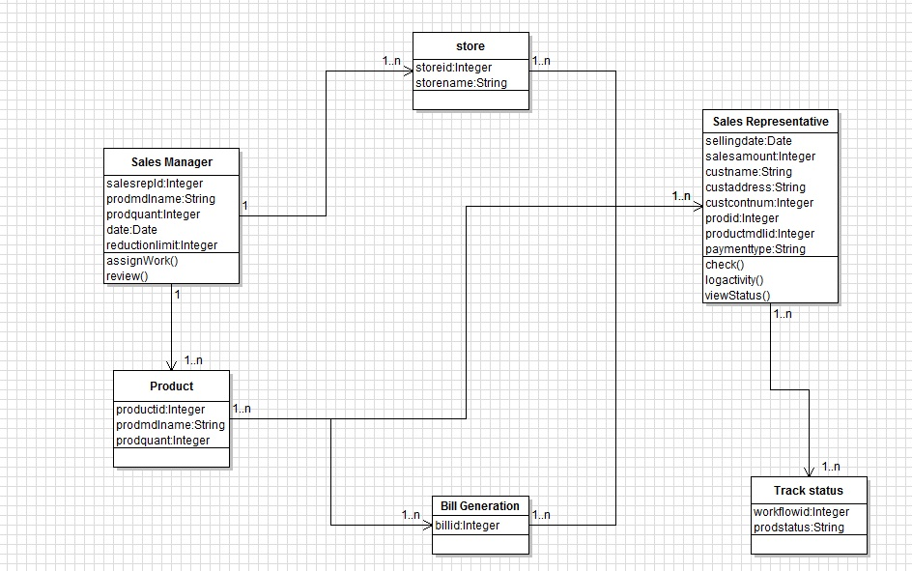

**UseCase Diagram (Sales Manager)**

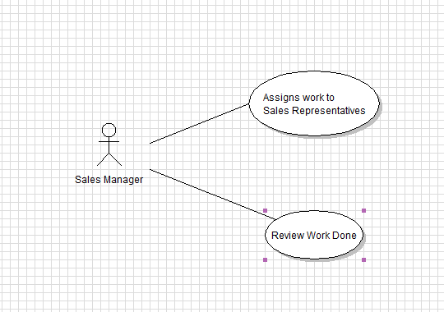

**UseCase Diagram (Sales Representative)**

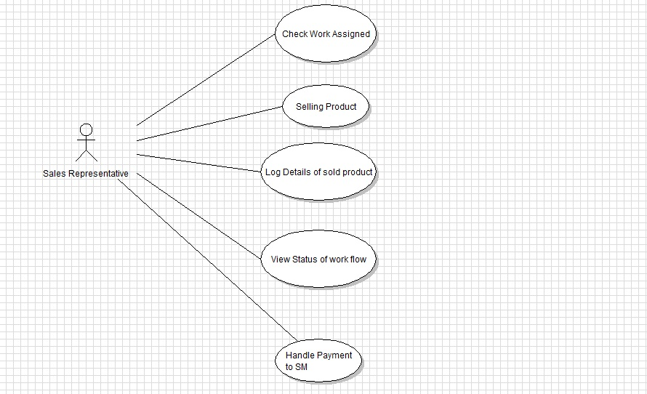

**The features implemented:**

1. SQL injection - prepared Statement

2. Cross site Scripting - we have used <C:out> to display

3. Secured password handling - one way hash & salting

4. Password Reset Facility to email - String Password Generation

5. User Type - Admin, Sales Manager, Sales Representative

6. MVC Pattern

7. Password validations thorough JavaScript function

8. Unique CSS Styles and separate files

9. Exception Handling

10. Code Written code with standard and Refactoring done